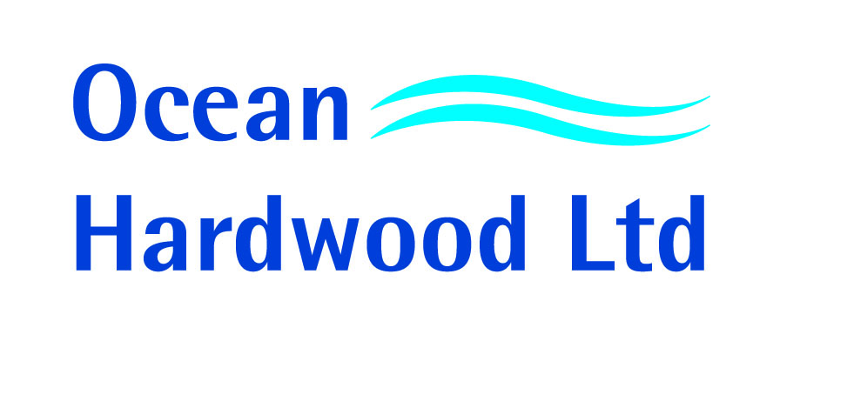
ENVIROMENTAL POLICY STATEMENT
In light of increasing concern regarding the supply of natural wood products from around the World,
Ocean Hardwood Ltd has decided to adopt a written environmental purchasing policy.

As of, Ocean Hardwood Ltd has been accredited Chain of Custody Certification to trade products under the following schemes:

FSC ® (Forest Stewardship Council®)
PEFC (Programme for the Endorsement of Forest Certification)

As of this date, wherever possible and viable, all suppliers capable of offering products covered under these schemes will be given preference. Any suppliers not covered under these schemes must be able to provide information relating to the legality of their supply.

Ocean Hardwood Ltd aims to provide its customers with the assurance that our products are able to meet their requirements and those of other 3rd party interests. To do this, maximum effort is being made to source the largest percentage possible of certified products. This can be assisted by our own customers where forecasts and programmes for the supply of certified material is given.

It is inevitable, due to the nature of the varied supply of hardwoods that there are products which are not currently covered by the aforementioned schemes. When this appears to be the case, suppliers are asked to provide Ocean Hardwood Ltd with information relating to the sustainability of the forest resource and any documentation which may help demonstrate good forest management and legal harvesting rights.

Our intention is, that year on year we will be able to offer a larger and wider range of products which meet the most stringent requirements of the independent certification schemes. This long term approach should make the future of our industry socially responsible, environmentally sound and economically viable.

We look forward to your long term partnership in our industry.

NICOLA CROSS
MANAGEMENT REPRESENTATIVE

