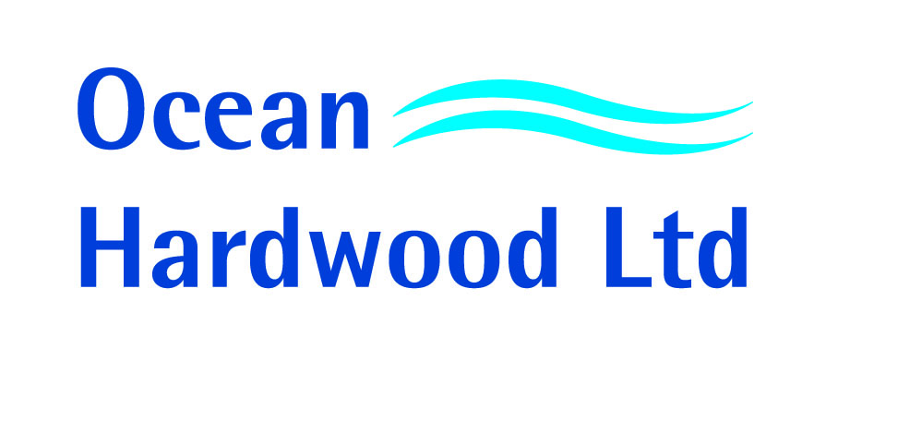ENVIROMENTAL PROCUREMENT POLICY
As part of our on-going commitment to buy and sell timber products which meet the demands of our customers we have established the following written Procurement Policy. All employees of Ocean Hardwood Ltd are expected when placing contracts with our suppliers to adhere to the principle that:

“Where possible, each purchase by Ocean Hardwood Ltd should aim to be environmentally sensitive, socially responsible and financially viable”.

1) Environmentally sensitive.
Ocean Hardwood Ltd will always give priority to those suppliers offering material with valid independent certification of the schemes to which Ocean Hardwood Ltd is accredited. If a supplier is not able to offer material covered by such schemes our purchases will take into consideration:
Proof of Legality (independently verified)
Other Certification Schemes
Purchasing & Environmental Policies
Future Commitments & Plans (Where the supplier is working toward any of the above)

2) Socially Responsible
We do not and will not trade with any companies where we are made aware of any proven instances of business practice which are internationally recognised as being socially irresponsible. We also aim to enhance our social environment locally though charitable donations and sponsorships. Should any member of Ocean Hardwood Ltd be made aware of a potential social issue, the matter will be reported immediately to senior management for further investigation & consideration.

3) Financially viable.
First and foremost Ocean Hardwood Ltd is run as a profit making business. Each business transaction is based upon its individual merits. If in any way a particular purchase is not reckoned to be financially viable, (however environmentally sound or socially responsible it may be) it is unlikely that the transaction will continue. This is not to say however that we will only take a short term view of purchasing procedure. Where in the medium or long term a bigger objective may be gained, some short term sacrifices will and have been willingly made.

Ocean Hardwood Ltd will implement its best efforts to avoid trading and sourcing wood or wood products from the following categories excluded under the Controlled Wood Standard:
a) Illegally harvested wood;
b) Wood harvested in violation of traditional and civil rights;
c) Wood harvested in forests where high conservation values are threatened by management activities;
d) Wood harvested in forests being converted to plantations or non-forest use;
e) Wood from forests in which genetically modified tress are planted.

Ocean Hardwood Ltd aims to work with our suppliers and customers to develop mutually beneficial relationships which cover all of the aforementioned.

STUART REA
DIRECTOR

